BT6270 : Computational Neuroscience

Assignment 2

--------------------------------------------------------------------------------------------------------------

**General Instructions:**

* The goal of this assignment is simulating and Understanding FitzHugh-Nagumo neuron model taught in the class.
* This is an individual assignment.
* You may use MATLAB or PYTHON for your implementation.
* You have to turn in the well commented code along with a detailed report of the study.
* Your report should contain answers for all of the questions/cases asked below.
* Look at the end of the assignment for submission instructions.
* **Submission deadline: 10th October, 2022 (23:59).**

____________________________________________________________________________________

_____________________________________________________________________________________

**Simulate the two variable FitzHugh-Nagumo neuron model using the following equations:**

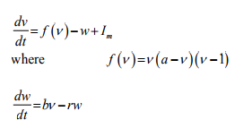

where a=0.5; choose b, r = 0.1)

**Use single forward Euler Integration**

dv/dt = Δv/ Δt

Δv(t) = v(t+1) - v(t) = [fv(t) - w(t) + Iext(t)]* Δt given v(0) --> v(Δt ) --> v(2* Δt ) -->....

**Case 1:** Iext = 0

(a) Draw a Phase Plot superimposed (use hold on command in MATLAB)

(b) Plot V(t) vs t and W(t) vs t and also show the trajectory on the phase plane for the both cases

(i) V(0) < a and W (0)= 0

(ii) V(0) > a and W (0)= 0

**Case 2:** Choose some current valueI1 < Iext < I2 where it exhibit oscillations. Find the values of I1 and I2.

(a) Draw a Phase Plot for some sample value of Iext

(b) Show that the fixed point is unstable i.e., for a small perturbation there is a no return to the fixed point (show the trajectory on the phase plane) – also show limit cycle on the phase plane

(c) Plot V(t) vs t and W(t) vs t

**Case 3:** Choose some Iext > I2

(a) Draw a Phase Plot for some sample value of Iext

(b) Show that the fixed point is stable i.e., for a small perturbation there is a return to the fixed point (show the trajectory on the phase plane)

(c) Plot V(t) vs t and W(t) vs t

**Case 4:** Find suitable values of Iext and (b/r) such that the graph looks as phase plot shown as below.

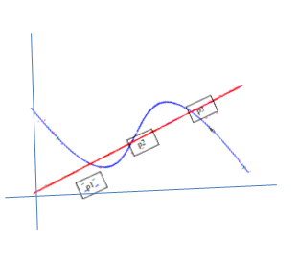

(a) Redraw the Phase plot

(b) Show stability of P1, P2, P3

(c) Plot V(t) vs t and W(t) vs t

**Submission Instructions**

Enclose all your programs, plots and report in a single zip folder

Please submit a compressed zip or tar file named as <ROLLNO>_A2.zip by sending it to one of the TAs via email (email IDs given below). Report should be very clear and all assumptions should be clearly highlighted.

Email IDs of the TAs

[sayanghoshbme@gmail.com](mailto:sayanghoshbme@gmail.com)

[sundarielango95@gmail.com](mailto:sundarielango95@gmail.com)